NEW COURSE / COURSE REVIEW TEMPLATE

Course Code:
Course Name:
Date:
Course Lead:
Department Chair:

COURSE REVIEW PROCESS
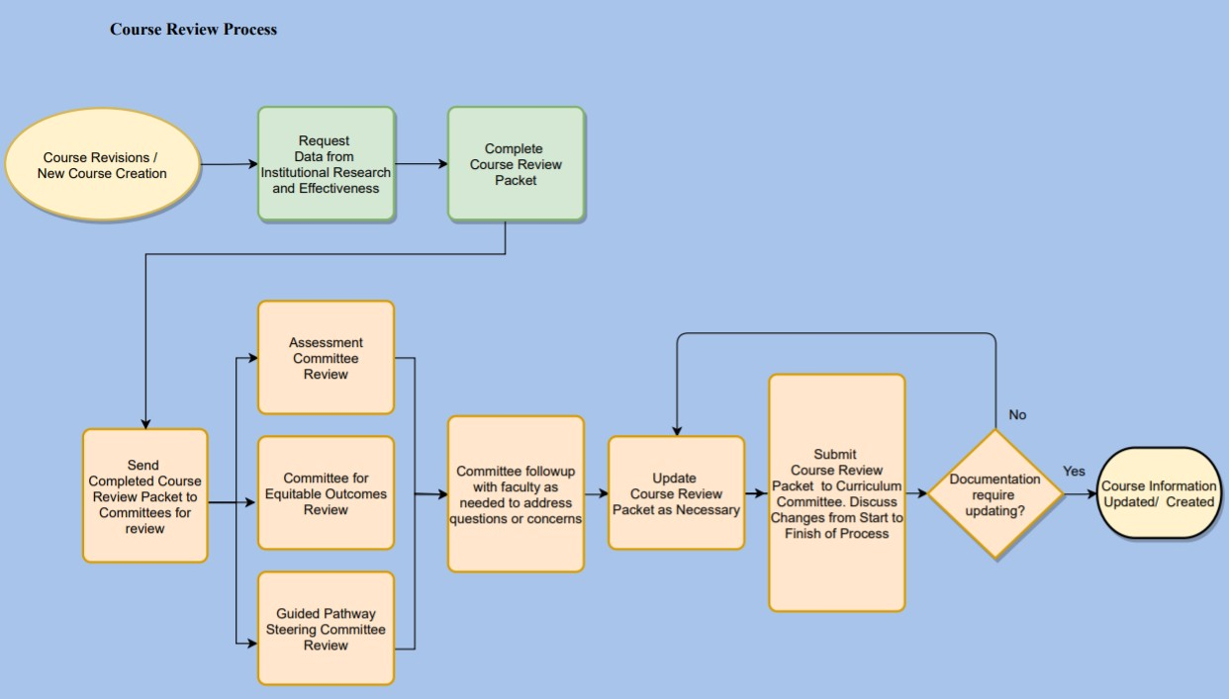

SECTION 1: COURSE REVIEW / NEW COURSE CREATION

STEP | COURSE REVIEW | NEW COURSE CREATION
1 | Update syllabus as needed and provide copy for each delivery method | Create syllabus using syllabus template for each delivery method
2 | Complete Taxonomy Summary  If changes are to be made, complete a Taxonomy Change Form first.  Make sure course description is the same in syllabus, Taxonomy Summary, and Catalog | Complete New Course Taxonomy  Make sure course description is the same in syllabus, New Course Taxonomy, and Catalog
3 | Evaluate course by completing questions found in each section of this document.  Assessment Guided Pathways  Committee for Equitable Outcomes | Evaluate course by completing questions found in each section of this document.  Assessment Guided Pathways  Committee for Equitable Outcomes
4 | Provide GEO Assessment Rubric if applicable and provide the most recent Assessment Success Data (course success data can be obtained by contacting the IR department). | Create GEO Assessment Rubric if applicable
5 | Review the current 5 course specific questions for Student Feedback Survey to determine if changes need to be made | Create 5 course specific questions for Student Feedback Survey

SECTION 2: ASSESSMENT

- Is the course description the same in the catalog, syllabus, and taxonomy form?

- Enter Official Course Description below:

- Is the language in the Course Outcomes/Educational Objectives measurable?

- List Course Outcomes/Educational Objectives below.

- If this course has pre-reqs, discuss and provide evidence that the pre-reqs are appropriate for this course.

- If appropriate, are General Education Assessment Outcomes explicitly stated in the syllabus and linked to course objectives? Yes No N/A (Skip to question 8)

- GEO(s) assessed for:
Attach a copy of the assessment rubric.
  - GEO Assessment (if applicable): Attach a copy of the most recent GEO assessment data (course success data can be obtained by contacting the IR department). Discuss the following: How have you revised the course based on the assessment data?

- Assessment Data: Attach a copy of the most recent course success data (course success data can be obtained by contacting the IR department).

  - Course Delivery – Discuss the following: How have success data compared between face-to-face and online sections? If delivery method data are disparate, what measures are being undertaken to address this?

- Closing the Loop: Has the Report Changes to Course and Close the Loop form been completed for this course within the last year? Yes No
Summarize the specific changes made to this course and their results.

COMMITTEE FEEDBACK:

ACTION PLAN:

SECTION 3: GUIDED PATHWAYS

- If this is a GEO course, is it included in the list of GEO options for programs in the catalog? Yes No N/A

- Is this course required for multiple programs in one or more Pathway?
  - If the scope is limited, can it be incorporated into other programs?

Yes No

  - If the scope is broad, have program maps been compared and aligned to ensure the course is scheduled in appropriate timeframes to meet student need and map requirements?

- Do we consider this a transfer course? Has course transferability been reviewed and verified within the last year?

COMMITTEE FEEDBACK:

ACTION PLAN:

SECTION 4: INCLUSION AND EQUITY

With these questions, instructors are asked to ensure that they promote inclusiveness
in the learning environment and understand the different barriers our student
population may face throughout the learning experience.

Please provide examples in your answers.

- How do you integrate equal educational opportunities in your curriculum and classroom?

- How do you adapt your teaching methods to accommodate student learning needs and abilities to promote equitable outcomes?

- How does your course promote inclusiveness and equity, and as the instructor, how do you ensure diverse perspectives are included?

- What assessment strategies and feedback practices are you using to promote equity and recognize the diverse strengths and contributions of all students?

COMMITTEE FEEDBACK:

ACTION PLAN:

SECTION 5: STUDENT FEEDBACK QUESTIONS

List the 5 course specific questions below that you would like used for the evaluations. Be sure to send these to the
Dean’s Department Coordinator to be added to the surveys.

If only using the 5 college questions and 5 departmental questions check here

TAXONOMY SUMMARY (IF REVIEWING CURRENT COURSE)

Summary Form TAXONOMY
(Master Course File)*

*All fields must be completed
DISCIPLINE | NUMBER

TITLE:
TITLE ABBREVIATION:
(20 characters)

________ Credit Hours (15 contact hrs = 1 cr hr)
Complete if applicable:
__________ Total Lecture Hours
__________ Total Lab Hours
___________ Total Clinical Hours
________ Billing Contact Hours (15 contact hrs = 1 cr hr)
_________ Instructor Load (1 BCH = 15 hours of load)
__________ Maximum Seating Capacity
_________ Instructor Permission (Y/N)
_________ Course Fee (Y/N) Academic Credential(s) Needed for Instructor Eligibility
_________ Pass or Fail Course (Y/N) _____________________________________________

Repeatable? May students take this course more than once for credit? If yes, please explain why.

Pre-Requisites Required:
Co-Requisites Required:
Special Program Requirements:

COURSE DESCRIPTION:

Signature of Department Chair / Date Signature of Academic Dean/ Date Curriculum Committee Chair / Date
Registrar / Date | ACS Code

NEW TAXONOMY FORM (IF CREATING NEW COURSE)

NEW COURSE Taxonomy (Master Course File)*
*All fields must be completed

Effective (First Offering) Date:
DISCIPLINE: ___________ NUMBER: ___________
TITLE: _____________________________________________________________
TITLE ABBREVIATION (for transcript) (< 20 characters):__________________________

________ Credit Hours (15 contact hrs = 1 cr hr)
Complete if applicable:
__________ Total Lecture Hours
__________ Total Lab Hours
___________ Total Clinical Hours
________ Billing Contact Hours (15 contact hrs = 1 cr hr)
_________ Instructor Load (1 BCH = 15 hours of load)
__________ Maximum Seating Capacity
_________ Instructor Permission (Y/N)
_________ Course Fee (Y/N) Academic Credential(s) Needed for Instructor Eligibility
_________ Pass or Fail Course (Y/N) _____________________________________________

Repeatable? May students take this course more than once for credit? If yes, please explain why.

Pre-Requisites Required:
Co-Requisites Required:

Does this replace a current course for all existing requirements? Which course?
Should the old course continue to fulfill all program requirements?
Should the old course be made inactive? If yes, please attach Taxonomy Change Form.
COURSE DESCRIPTION: (Be succinct)

Department Chair / Date | Academic Dean/ Date | Curriculum Committee Chair/Date

Registrar / Date ACS Code

GLOSSARY AND EXPLANATION OF TAXONOMY CELLS

Credit Hours | Hours listed on the transcript
Billing Contact Hours | Generally the same as the Credit Hours, unless there is a lab attached. If there is a lab, the standard calculation is 3-4 hours of lab equals 1 credit hour. The actual hours the class  meets each week are the BCH.
Course Fee | If your course is deemed to have course fees, please contact the JetStore Manager with what items you plan to use/order and the approximate costs.
Pass or Fail Course | This is a N if a grade will be given in this course. Most courses are NOT Pass or Fail.
Academic Credential needed for Instructor eligibility | Here you will enter in the discipline or program.
Credit Type | For academic courses, you would put I for institutional
Continuing Ed Units | This would only have something entered if this a course used for CE
Instructor Load | This is the total load based on the billing contact hours. To determine this number, take the billing contact hours and multiply by 15, regardless of whether the class is offered for  15, 12, 7 or fewer weeks.
Maximum Seating Capacity | This is often based on standard class size or accreditation requirements. Check with the scheduling office to determine what the standard is for this class type.
Instructor Permission Required | This is generally only used in courses such as a capstone or work experience where students must have approval to be  enrolled.
Repeatable? | For most courses this answer will be NO as there are rare instances where a class can be taken more than once for credit.

