COURSE REVIEW REPORT

Course: _HPF 161 Personalized Fitness
Faculty Member Completing Review: _Payge Hodapp Date: _1/15/2014
Please submit two complete printed copies, and an electronic copy, of the course review packet
(this form and all attachments) to the Curriculum Committee for approval. Detailed instructions
can be found at http://www.jccmi.edu/administration/deans/CourseProgramForms.htm.

Submit written responses to all of the following items:
General Information
1. Has the course been taught in the last two years? Yes – see document 1. Semester last taught 14WN If it has not been taught in the past 2 years, explain why. N/A

2. Describe the target students for this course. Students in all programs of study can take this course as an elective to encourage exercise for personal interest, to manage stress, to balance out a heavy mental course load or to total enough hours for aid or a scholarship or employment.

Is the course being scheduled at times/locations that best serve the target students? Explain. HPF 161 is serves best the students who are face-to-face and take classes on Central Campus. The Weight Room and LTL Activity classes in which students can also participate as a benefit of taking this class are offered on Central Campus.

3. Is at least one full-time faculty member involved in teaching this course? No If not, please explain. The Adjunct instructors for this class are highly competent with years of experience teaching fitness classes. The HPF Department currently has no full time faculty employed.

Documentation
1. Is the course description the same in the catalog, taxonomy summary, official course outline and syllabi? Yes see documents 2-5. (If necessary, attach a taxonomy change form to update the catalog description.)
Catalog: http://www.jccmi.edu/studentservices/Catalog/2013-2014/catalog/coursedescriptions.pdf
A self-paced program in which students exercise independently in a JC supervised lab. Instructor’s guidance is available to develop an individualized plan to achieve personal health and fitness goals.
Taxonomy: A self-paced program in which students exercise independently in a JC supervised lab. Instructor’s guidance is available to develop an individualized plan to achieve personal health and fitness goals.
Official Course Outline: A self-paced program in which students exercise independently in a JC supervised lab. Instructor’s guidance is available to develop an individualized plan to achieve personal health and fitness goals.
Syllabus: Personalized Fitness is a self-paced program in which students exercise independently in a JC-supervised lab. Instructor’s guidance is available to develop an individualized plan to achieve personal health and fitness goals.

The same description is found in the catalog, taxonomy summary, official course outline and course syllabus.

2. Is the Official Course Outline current? Yes – see document 4.. Update as needed and attach a copy. Updated 11/13
Attach an updated copy of the Taxonomy Summary form (incorporating any recent taxonomy changes). Attached- see document 3.

3. Are the official course description and objectives consistent with what is taught by all faculty/all methods (full-time, part-time, face-to-face, online)? Yes If not, please explain. Discuss how that consistency was developed/is maintained.
The syllabus topics and assignments are standard for all classes.
Instructors spend their assigned teaching hours in the Weight Room on a weekly basis and often will spend one of their hours working there together, using the opportunity to share experiences and collaborate on ideas.
At times, the HPF instructors have separate hours working as Weight Techs in the Weight Room and so have the opportunity to observe how the students are making use of the facility. This provides useful information on problems and opportunities that can be shared with other instructors and Weight Techs.
The two instructors who teach this course on an ongoing basis communicate regularly on course progress and improvements. (When enrollment is down, a single instructor teaches all sections.) Often times, the syllabus will be improved for the following semester, based on the experience of the current semester.
Weight Techs and Instructors mix regularly and are able to share information face-to-face or via email.
4. Are prerequisites appropriate to the content and correctly listed in the catalog and syllabi? No prereq.
List the prerequisites: N/A.

5. If this course is a prereq for another class, have the two departments/lead faculty coordinated? Not a prereq for another course. List the course(s) for which this is a prereq: N/A

6. When was the syllabus last updated? 14WN Attach copies of the most recent syllabi, including copies of both face-to-face and online section syllabi. See document 5; face-to-face sections only.

Discipline and Quality
1. What instructional methods are used (e.g. PowerPoint, group work, service learning, laboratory, etc.)? Discuss the effectiveness of these methods. Are there methods you would like to use but cannot for any reason? Explain There is an initial required, face-to-face Orientation during which the syllabus, expectations and grading are reviewed via lecture and course handouts. The Weight Room is visited and equipment there is demonstrated. Initial Fitness testing is completed under the supervision of the instructor.
Students are then encouraged to work out 2-3 times a week at convenient times in the Weight Room which is staffed by experienced Weight Techs who are there to provide help with machines and workout plans if desired. The instructors have posted hours when they are available in the Weight Room for specific questions and concerns.
Support materials are available via JetNet which is used for the submission of assignments.
We have found that attendance in the initial Orientation is a key indicator for success. Colleague is not currently programmed to share the details of the Orientation with E-Services/My Class Schedule. As a result, students cannot easily access this information. To remedy this, a letter is sent via USPS to arrive a week before the Orientation and an email is sent out about a week before and then again a day or two before the Orientation. These practices have improved attendance. However, some students do not give JC their change address and others do not check JC email. When budget permits, it would be of great advantage to have this crucial information (Orientation date/time/location) available in each student’s My Class Schedule” in E-Services.

2. Are Associate Degree Outcomes explicitly stated in the syllabus and linked to course objectives? Yes ADO(s) assessed for: The primary Associate Degree Outcome addressed in this class is: acknowledges responsibility for personal health and well-being (ADO8).
In this course, each student will develop a personalized exercise plan, build a routine for working out on a regular basis and take responsibility both for improving their wellbeing and completing the course responsibilities.

3. Attach a copy of the most recent assessment success data. This course is not assessed.
How have you revised the course based on the assessment data? N/A
How have assessment data compared between face-to-face and online sections? N/A
If disparate, what measures are being undertaken to address this? N/A

Currency
1. Describe process(es) used to monitor/maintain currency/changes for this course. Attach supporting documentation as needed/appropriate. The course is reviewed annually on a number of levels:
1) Format and delivery: Feedback is gained primarily from student evaluations. There is an anonymous, computerized evaluation done toward the end of each course (example attached as document 6).
2) Improvements are made on a semester-by-semester basis, based on instructor experience and student feedback.
3) At least once a year, there is an HPF departmental meeting of instructors. (Agenda attached a document 7.)
4) Individual instructors bring their personal expertise and training to the classroom and their colleagues, including continuing education within their field of expertise, reading of professional journals, articles and books, conference attendance, etc.

2. What is the copyright date of the textbook? No textbook is used.
If the book is more than 4 years old, include the rationale for its continued use. N/A

3. Is the course a component of a recent program review action plan? No. The Program Review will take place in April, 2014. If yes, describe actions taken. N/A

4. Is current technology appropriate/necessary to the course or field included in the content and/or methods? The course uses JetNet for assignment submissions and communication related to due dates, announcements, etc. Use of PowerPoint presentations, internet research and audio or video content is possible on Main Campus. Technology is involved in monitoring blood pressure and some of the fitness assessments as many of the pieces of equipment used for muscular and cardiovascular conditioning now require some level of technological understanding for use and operation. Are necessary equipment and aids current? The Weight Room equipment is extensive and functional. However, it is aging and would do to have an overarching plan for equipment replacement. Describe the technology used. JetNet.

Transferability
1. Are the course requirements and prerequisites consistent with requirements for comparable courses at other colleges? Yes Explain Generally, this course transfers for credit as an equivalent course or as a general transfer credit.

2. How does the course transfer? (Provide course number when equivalent) See document 8.
Institution | Equivalent Course | General Credit | No Credit | Unknown
SAU | HPF 160 plus HPF 161 = HPR 101 (2 credits)
SHU | PE Activity credit
EMU |  | PEGN General transfer credit (1 cr.)
GVSU |  | PED 100.0 General Credit (1 cr.)
MSU |  | KIN INST (1 cr.)
WMU | PEGN 1750 (1 cr.)
UM - Flint |  | KIN INST (1 cr.) | X
Explain any transfer problems.
University of Michigan (Ann Arbor) will not transfer any HPF courses.

For Occupational Courses Only
1. Is this a required course in an occupational program? Y/N Which program(s)? text

2. When was this course last discussed at an Advisory Committee meeting? _date
How do external partners have input into this course? text

3. Have recent course/taxonomy changes been communicated to all programs that require this course? Y/N Explain text

Attachments to include (print and electronic):
_☒_ Current syllabus (at least 1 from each delivery method) Face-to-face is the only delivery method. Document 1
_☒_ Catalog course description – found herein – document 2.
_☒_ Taxonomy Summary form, including any recent changes – document 3
_☒_ Official course outline – document 4
_☐_ Assessment Plan (electronic copy to Assessment committee if it has been updated or not submitted previously) N/A
_☐_ Most recent assessment success data tables N/A
_☒_ This completed form
_☒_ Other supporting documentation/answers to questions/explanations: HPF 161 Course Tally information (document 5), Student Course Feedback (document 6), HPF Dept. Meeting Agenda (document 7), Transferability information(document 8)

For Committee Use: COMMENTS _______________________________________________________________

____________________________________________________________________________________________

Date reviewed ____________ Satisfactory/Needs more information Date approved ___________________

Course Tallys showing HPF 161 runs in Fall, Winter and Spring
Document 1

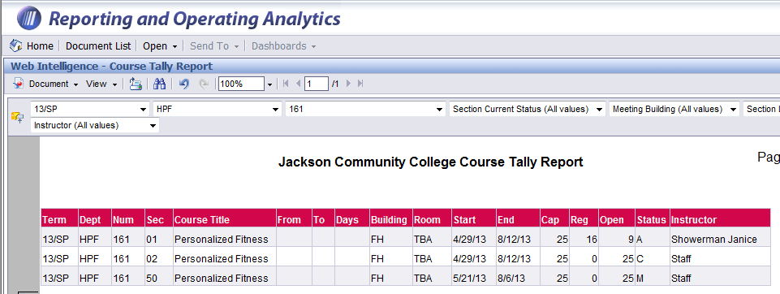

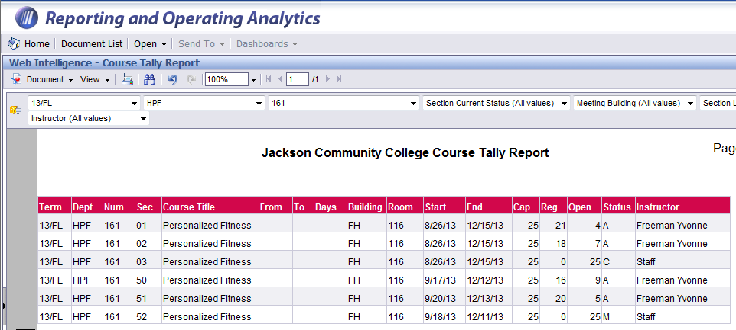

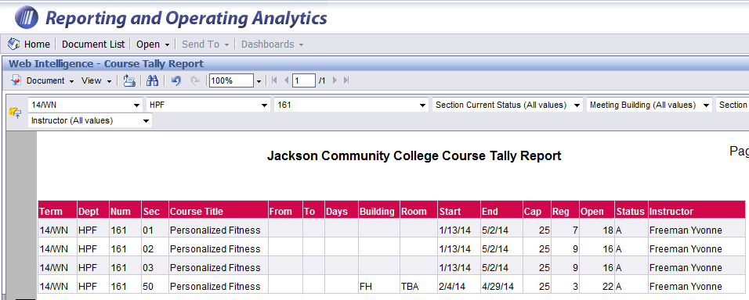

Document 2

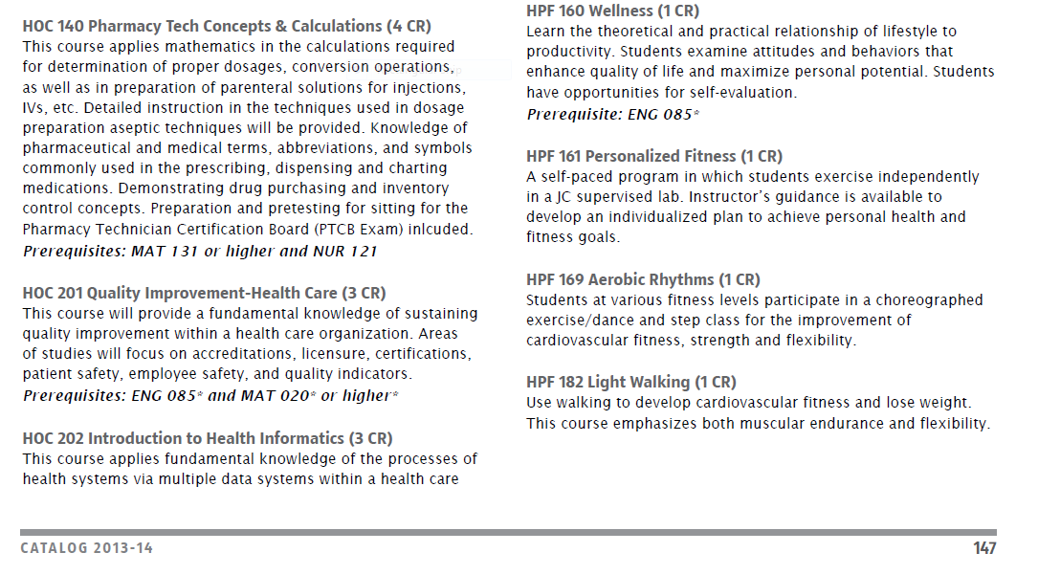

Document 3

Summary Form

TAXONOMY

(Master Course File)*

*All fields must be completed

Effective Date: 11/01/13
HPF | DISCIPLINE | 161 | NUMBER

TITLE: | Personalized Fitness

TITLE ABBREVIATION: | Personalized Fitness
(20 characters)

1 | Credit Hours  (15 contact hrs = 1 cr hr) | I | Credit Type  I=Institutional C=Cont Ed
1 | Billing Credits (BCH)  (15 contact hrs = 1 BCH) | N | Continuing Ed Units
$29 | Course Fee | 1 | Instructor Load (1 BCH = 15 contact hrs)
N | Pass or Fail Course (Y or N) | 30 | Maximum Seating Capacity
 |  | N | Instructor Permission Required (Y or N)

Number of times course can be taken for credit (most courses are one time – see Registrar for options)
1

Pre-Requisites Required: | None

Co-Requisites Required: | None
Special Program Requisites: | None

COURSE DESCRIPTION:
A self-paced program in which students exercise independently in a JC supervised lab. Instructor’s guidance is available to develop an individualized plan to achieve personal health and fitness goals.

Signature of Department Chair / Date Signature of Academic Dean/ Date Curriculum Committee Chair / Date

Registrar / Date | ACS Code

Document 4

JACKSON COLLEGE OFFICIAL COURSE OUTLINE

Course number, title and credits; total time allocation
Course Letter/Number |  | HPF 161 |  | Credits |  |  | 1 |  | Title | Personalized Fitness
Lecture/Discussion | 1 |  | hrs/semester |  |  | Lab |  | 0 |  | hrs/semester |  | Clinical | 0 | hrs/semester

Catalog Description and Pre- and Co-requisites (Same as taxonomy and catalog)
A self-paced program in which students exercise independently in a JC supervised lab. Instructor’s guidance is available to develop an individualized plan to achieve personal health and fitness goals.

Knowledge, Skills and Abilities Students Acquire from this Course (Educational Objectives)
- To experience working with health and fitness-related goals.
- To improve one's level of fitness through a regular program of exercise.
- To become motivated to assume a greater sense of personal responsibility for one’s health and fitness.
- To complete all assignments, whether working out or written, in a timely fashion.

Associate Degree Outcomes Addressed in this Course (These must appear in course syllabus.)
The primary Associate Degree Outcome addressed in this class is: acknowledges responsibility for personal health and well-being (ADO8).
In this course, each student will develop a personalized exercise plan, build a routine for working out on a regular basis and take responsibility both for improving their wellbeing and completing the course responsibilities.

Units/topics of Instruction
- Initial Orientation to HPF 161 and Weight Room
- Developing personal health or fitness related goals and working toward them on a weekly basis, with regular workouts in a JC-supervised lab .
- Research in a health- or exercise-related area of interest
- Reflection on personal progress

Instructional Techniques and Procedures
An initial required orientation provides an overview of course expectations, due dates and an introduction to the Weight Room and the equipment there. The instructors have regular hours in the Weight Room for personalized coaching and input. At other times, trained Weight Technicians are present to teach use of the equipment and advise students on work out routines. Students are encouraged to set personal goals to target their efforts over the course of the semester. Written work is centered on encouraging and supporting progress with these personal goals.

Instructional Use of Computer or Other Technology

Written assignments are submitted on JetNet.

Instructional Materials and Costs to Students
No text
Course fee: $29

Skills and abilities students should bring to the course:
 | X | a limited amount of material |  |  |  | basic, pre-algebraic problems
Able to read |  | an average amount of material |  | Able to compute |  | simple algebraic problems
 |  | an above average amount of material |  |  |  | higher order mathematical problems
 | X | relatively easy material |  |  | x | short compositions
Able to read |  | moderately difficult material |  | Able to write |  | medium length compositions
 |  | technical or sophisticated material |  |  |  | lengthy compositions
 | X |  | keyboard skills/familiar with computer
Able to use | X |  | computer application (Use of JetNet) | Other necessary
technology |  |  | web navigation | Abilities

The course is usually scheduled: (This refers to Orientation only; students may workout whenever the Weight Room is open.)
Day: | X | Fall | X | Winter | X | Spring | Evening: | X | Fall | X | Winter |  | Spring

Prepared by ___________Payge Hodapp________________ |  | Date __11/05/13_____________________
Approved by Dept. ___________________________________________________ |  | Date __________________________________
Approved by Dean ___________________________________________________ |  | Date __________________________________
Approved by Curr. Comm. _____________________________________________ |  | Date __________________________________
(Last names, please) Form Revised 12/4/00

Course Syllabus
Document 5
HPF 161 Personalized Fitness (1 credit)
An opportunity to enhance and improve your physical fitness
in an individual and personal way…

Course Information
INSTRUCTORS
Janice Showerman
Yvonne Freeman
TECHNICIANS
Katie Crowley Rex Holmes
Dan Wandell Janice Showerman
Yvonne Freeman Teresa Klaassen
Ralph Fogarty Jon Packer
PHONE
(517) 796-8455 Main Office
(517) 796-8679 Wt. Room
EMAIL
Yvonne: freemanyvonnes@jccmi.edu
Janice: showermjanicej@jccmi.edu

OFFICE HOURS
Janice Showerman MWTh 11am-1pm
Yvonne Freeman MW 10am-12pm &
T 11am-1pm

Open Workout Hours
Check at the Weight Room desk or the FH office for a current schedule.
Course Description: Personalized Fitness is a self-paced program in which students exercise independently in a JC-supervised lab. Instructor’s guidance is available to develop an individualized plan to achieve personal health and fitness goals.
This course is about you and is
designed for your success!
- Flexible workout hours are available to meet your ever-changing schedule.
- Individualized instruction is available at your request.
- This is an opportunity to work on goals of your choice.
Associate Degree Outcomes
The Board of Trustees has determined that all JC graduates should develop or enhance certain essential skills while enrolled in the college. The primary Associate Degree Outcome addressed in this class is: acknowledges responsibility for personal health and well-being (ADO8).
In this course, each student will develop a personalized exercise plan, build a routine for working out on a regular basis and take responsibility both for improving their wellbeing and completing the course responsibilities.
Responsibilities and Assignments
Orientation
  - Attend the required, scheduled Orientation. If unable to attend, contact your instructor prior to the Orientation to make other arrangements.
  - Read and complete all materials: Release & Waiver Form, Syllabus, Personalized Fitness Student Handbook, Goal and Prescription Worksheet.
  - .Complete blood pressure testing and Target Heart Rate training. Record the results on your workout card.
  - Listen with attention during the Orientation to prepare for the Online Quiz
Workouts
- Workout at least two times per week, three is ideal for best results. The week starts on Monday.
- The minimum requirement is 30 workouts during the semester for a minimum of 40 minutes per workout. Only one workout per day and up to three per week may be counted.
- Sign in at the start of your work out in the Sign In Sheet Notebook. Print your name so it is legible and your start time.
- Have an instructor or tech date, initial and stamp your card each time you complete a workout. Record you completion time in the Sign In Sheet Notebook.
- A benefit of enrolling in any HPF class is that you may attend other HPF/LTL activity classes (Spinning, Aerobics, Yoga, Light Walking) on Main Campus as space permits. Attending one of these classes may also count as a workout one-to-one. But students registered in more than one fitness class must achieve the required workouts for each class independently.
- Workouts must be done at a JC facility or in JC classes.
- If you are not attending on a regular basis, your instructor is required to drop you from the course for non-participation when HVQ grading is due. It is your responsibility to keep your instructor informed about unusual workout patterns. PHONE, EMAIL or LEAVE A NOTE.
- Athletes: Team practices that are coach-led or games are not counted as workouts for the purposes of this class.
Written Work
- Complete Goal and Prescription Worksheet DUE BY END OF ORIENTATION.
- Mid-term Assignment due Week 7 – DATE_____________________________
- Final Summary Reflection Assignment due Week 14 – DATE ______________________
- Students who fail to complete at least one of the written assignments (Assignment One, Assignment Two) will receive no grade higher than a 1.5.
GRADING AND POINTS
4.0 | 189-200 |  | Required Orientation and Release & Waiver Form | 0 - 15 pts
3.5 | 178-188 |  | - Attend at a scheduled time | (15 points)
3.0 | 167–177 |  | - Late, abbreviated, with instructor (within 1 week following your scheduled orientation) | (5 points)
2.5 | 156–166 |  | - Late, abbreviated, with instructor (after 1 week following your scheduled orientation) | (0 points)
2.0 | 145–155 |  | Goal and Prescription Worksheet (due at end of Orientation) | 10 pts
1.5 | 134-144 |  | Orientation Quiz (online) – DATE _________________ | 10 pts
1.0 | 123-133 |  | Assignment One due Week 7 – DATE__________ | 20 pts
0.5 | 112-122 |  | Assignment Two due Week 14 – DATE _________ | 20 pts.
0.0 | ≤ 111 |  | Final Evaluation (online) DATE ________________________ | 5 pts
 |  |  | Workouts (30 @ 4 pts each) | 120 pts
 |  |  | Total | 200 points
Note: Midterm grades are based on the completion of 15 workouts as well as all other assigned work required up to that point in the semester.
Plagiarism and Cheating
Be sure that all homework and assignments are your own work. Evidence of plagiarism or cheating on any exam or assignment will result in a "0" score for that assignment and notification of the Academic Dean. The JC Academic Honesty Policy can be found in your student handbook or on the JC website at this web address: http://www.jccmi.edu/policies/Academics/Policies/1004.pdf
I – Incomplete
For the JC Incomplete grade policy, please visit:
http://www.jccmi.edu/policies/Academics/Policies/1003.pdf
HELP
Tutors (plus additional services for academic success) can be accessed by calling 517- 796-8415 or by stopping by the Center for Student Success, Bert Walker Hall Room 123 on the Jackson Campus or the office at either JC @ LISD TECH, Adrian or the LeTarte Center, Hillsdale.
Students with disabilities who believe that they may need accommodations in this class are encouraged to contact the Center for Student Success at 517-796-8415 as soon as possible to set up a meeting to ensure that such accommodations are implemented in a timely fashion. It is the responsibility of the student to self-report needed accommodations to the CSS
Keeping on Track
Know your instructor. YOU SHOULD DIRECT ALL REPORTS AND COMMUNICATION ABOUT HEALTH ISSUES AND GRADING TO YOUR INSTRUCTOR.
Stuff happens. Job changes, illnesses, family problems are all part of life you sometimes can't control. IF YOU THINK YOU'LL HAVE TROUBLE COMPLETING THE COURSE REQUIREMENTS, TALK TO YOUR INSTRUCTOR. Most situations can be worked out one way or another. Let your instructor know as soon as they occur.
We're here to help...
The Weight Training and Conditioning Center is supervised at all times. All instructors and technicians can assist you with use of equipment and answer your questions or help you adjust your workout.
Workout Expectations
Each time you enter the Conditioning Center, the following are required to receive credit for your workout:
- Sign-in using the Sign-in Sheet Book.
- Complete a 40 minute workout that includes an adequate warm-up, cardiovascular and/or strength component, a cardiovascular cool-down and some stretching.
- Have your workout card stamped and initialed by the instructor or technician on duty.
- Sign out using the Sign-in Sheet Book.
Miscellaneous
Students should be properly dressed for physical activity. Clothing should allow for free movement. Tennis shoes with closed toe and closed heel are required.
Locker rooms are available. Students must bring their own locks. DO NOT leave valuables in lockers.
Bring your own towel when you workout. Please wipe off each piece of equipment when you are done. Cleaning products are supplied.
IMPORTANT:
ALL PARTICIPANTS ARE REQUIRED TO SIGN A RELEASE & WAIVER FORM AND MUST SIGN-IN EACH CLASS SESSION.
PLAN AHEAD. UP TO THREE WORKOUTS PER WEEK (NO MORE THAN ONE PER DAY) COUNT TOWARD YOUR 30 WORKOUT TOTAL.
CHILDREN ARE NOT ALLOWED IN CLASSES IN THE FIELDHOUSE GYM OR IN THE WEIGHT TRAINING AND CONDITIONING CENTER.

ASSIGNMENTS and REFLECTIONS
If you are taking HPF 161 for a grade, you must complete two written assignments.
- Each assignment is worth 20 points.
- Assignments are to be SUBMITTED VIA JetNet BY DUE DATE (as identified in Orientation). Assignments submitted as hard copy or via email WILL NOT BE ACCEPTED.
- Assignments are to be formatted as .rtf (Rich Text Format)
- NO LATE ASSIGNMENTS
- Correct spelling, punctuation and grammar are to be used or points will be deducted. (Use your spelling and grammar checker if need be.)
Assignment One due Week 7 – DATE __________
Complete ONE of these options:
- Read and report on an article from a medical journal, or reputable health or fitness magazine
related to your goal OR on a topic of interest
OR
- Visit and report on health or wellness related website
related to your goal OR related to an area of interest
The website must be one that is maintained by a reputable organization such as a university, a hospital or a fitness, nutrition or health association such as The American Heart Association. A list of preferred or favorite sites is available in the Weight Room. Ask your instructor for assistance, if needed.
FORMAT OF REPORT:
- One page, double spaced, size 12 font.
- Saved as .rtf (Rich Text Format)
- Submitted via JetNet (Instructions for submitting on JetNet can be found in the Resource Materials on JetNet.)
Your Report should be set out in the following parts to receive full points:
Part 1: A brief summary of the information found in the article or on the website (4 pts)
Part 2: Identify four concepts or ideas that you found interesting and explain why in a sentence or two for each concept. (4 pts)
Part 3: Share in what ways (at least 2 ways) your research was helpful or not helpful to you. (4 pts)
Part 4: Share how you are using the information in your life and/or work outs? (4 pts)
Part 5: Citation (4 pts)
- For journal or magazine: Cite title of article, author, journal or magazine from which it was obtained and the date published.
- For website: List the exact URL, the organization that manages the site and the date that you visited it.

Assignment Two due Week 14 – DATE ______________
Type a 1 page (minimum) summary of your experience. Discuss the following aspects, setting out as described here.
- YOUR PLAN: What was your original plan? Did it change over the semester? Is so, how did it change and why? (5 points)
- DID YOU REACH YOUR GOAL? (10 points)
In answering this, include responses to the following:
  - Answer YES or NO (Did you or didn’t you reach your goal?)
  - What helped you? What were your wins, gains or benefits?
  - What got in the way? What were the challenges and difficulties?
  - Did anything unusual, ambiguous or surprising occur?
- MOVING AHEAD (5 points)
How do you feel now? What, if anything, will you continue? What might you think about doing instead or in addition?
Remember to take some time to celebrate the progress you have made!
Submitting Assignments
To find Microsoft WORD on a computer:
- At the bottom of the screen, look for “Frequently Used >>”.
- Click on it, and on the drop down menu, find ‘Microsoft WORD 2007’
- Click on this to open it.
- Word process your assignment.
- Use the Spelling and grammar tool in the Review Tab to check spelling and grammar
- Save your document onto your computer of flash drive in a place you can find it
- Save it as Rich Text Format (.rtf). This can be found in the ‘SAVE AS type’ drop down menu under the space where you give your paper a title
Then go into your course in JetNet
- Find the assignment name and click on it.
- Below the description, you will find a “BROWSE” button. Click on BROWSE and you can look into your computer or flash drive to locate your assignment.
- Click on your saved assignment to highlight and you will see it appear in the BROWSE box.
- Click on SUBMIT and your assignment has been submitted
Final Evaluation (online) – DATE______________
The final Evaluation can be found online in the resources in the last two weeks of classes. It is anonymous. Simply answer the questions as completely as possible. This will help us assess the usefulness and quality of the course this semester.

Note: This syllabus is subject to change as needed.
Weight Room Rules and Safety Policy
Who can use the Weight Room
- The Weight Room is open to those who are currently registered in an HPF class or LTL fitness class, currently living in Campus Housing, student-athletes or coaches.
  - The minimum age requirement is 14. LTL-enrolled students under the age of 18 must be accompanied by a parent or guardian while in the Weight Room.
General Guidelines
- Water, electrolyte drinks, etc., need to be contained in non-glass, lidded holders.
- No food, tobacco, glass bottles or cans are allowed.
- Chewing gum is discouraged. Dispose of used gum in the waste bin.
- Respect for those working out as well as the equipment and environment is expected.
  - Profanity, excessively loud or suggestive language will not be tolerated
  - To prevent health issues due to allergies, asthma and sensitivities, please avoid using or wearing strongly scented lotions, colognes, etc.
- Appropriate exercise attire is required in the Weight Room.
  - Shirts and closed-toe and closed-heel athletic shoes are required. Jeans are discouraged.
- All personal items should be locked in a locker or set out of the way on the shelves.
- Personalized Fitness Students need to both sign in and get their logs stamped on completion of their workout out every time they use the Weight Room.
Use of Equipment
- All participants should wipe down equipment with provided wipes when finished.
- All equipment must be used in the manner for which it is designed.
  - Use the equipment only when you are familiar with its use.
  - To learn correct usage, please ask a weight technician for instruction.
- Patrons should use extreme caution in lifting weights to avoid potential injuries to themselves or others.
- When using a cardio machine (treadmill, EFX, etc.), please limit use to 20 minutes if others are waiting.
- Please unload weights from machines when finished.
Safety Policy: The Instructors and Weight Technicians have the obligation to remove any student from the class environment/facility who compromises his or her own safety or the respect or safety of another. Re-admission to class or Weight Room will be on a case by case basis pursuant to a review of the situation by the Dean of Instruction and best practice.

Document 6
HPF 161 13FL Course Evaluation (2 sections)
Feedback: 24 students
Questions: 18
Question | Responses
Did you review the syllabus outside of class? | I read the syllabus carefully and understood the course expectations for grading (0) | I read the syllabus and understood most of the course expectation for grading (0) | I read the syllabus and was unclear about what it would take for me to pass the course. (0) | I did not review the syllabus. (0) | Average
 | 17 | 6 | 0 | 1 | 0
Do you feel the course accomplished the goals published in the syllabus? | Exceeded my learning expectations (0) | Met some of my learning expectations (0) | Did not meet my learning expectations (0) | Did not have any expectation (0) | Average
 | 14 | 10 | 0 | 0 | 0
Do you have any comments or recommendations related to the syllabus?* | I have no comments or recommendations for this course syllabus; No; similar comments: 10
 | Instructor did really well explaining the material and what was expected
 | No i comprehended everything that was expected of us for this course
 | No, it was basically clear to everything that should be expected.
 | No, everything seemed pretty clear.
 | No, it was very detailed.
 | We did not really go over it very much in class .
 | I have no recommentdations for the instructor related to the Orientation.
Did you attend other exercise classes as part of your Personalized Fitness work outs? | No (0) | Yes (0)
 | 19 | 5
If you attended other fitness classes as part of Personalized Fitness, please note which ones and how often during this semester. | No or similar x3
 | I went twice this semester to Weight training.
 | 3 times I ran a half marathon and several runs at JCC.
 | zumba
 | I have done a lot of my at home workouts as well as runnind dogs at the Cascades Humane Society in Jackson 2-3 times a week.
When using the Weight Room, how helpful were the Weight Techs? | Extremely helpful (0) | Very helpful (0) | Somewhat helpful (0) | Some were more helpful than others (0) | Not helpful (0) | I did not make use of the Weight Techs (0)
 | 9 | 10 | 2 | 2 | 0 | 0
Do you have any recommendations or comments on the Weight Room Technicians ? | No x 6
 | The 3 tvs in the weight room should all be on different channels to provide variety for the variety of people working out.
 | Dan was an extremely possitive and upbeat supporter of everyone he came in contact with.
 | They were all great, and willing to help whenever asked!
 | I do not have any recommendations or comments on the Weight Room Technicians.
 | They were very helpful.
 | I can't really think of anything to say that would help make the Weight Room Techs more helpful than they already are. If the kids needs help or have a question they should ask them it.
Do you have any comments or suggestions on how to improve the Educational Assignments? | No, no comment or similar x 9
 | They were great and I enjoyed the,
 | The education assignments were a little unclear as to how grading would be done.A syllabus in the future would be helpful! :)
Approximately how much time did you spend, on average, on the required work outs each week? | More than 8 hours a week (0) | 6 - 8 hours a week (0) | 4 - 6 hours a week (0) | 2 - 4 hours a week (0) | 1 - 2 hours a week (0) | Less than an hour a week (0)
 | 0 | 1 | 5 | 17 | 1 | 0
What was your most significant learning or change while taking this class? | lost weight
 | I learned that even though you are working out it isnt beneficial to you until you reach that workout zone where your heart is working enough
 | I learned how to make time for exercize and hewalthy eating.
 | Time managment
 | Time management
 | losing weight
 | I learned how to use the different machines in the weight room to help tone my arms and legs.
 | weight loss
 | My most significant thing I learned in this class was to find my potential heart rate that I need to get a good workout in.
 | Learning that the best way for me to become more active was to entertain myself with things like music and books to let go of reservations I was holding onto.
 | The most significant thing about this class was the ability to get in the weight room and put some work in to better you physically
 | My most change while taking this classs was gaining muscle in my legs as well as toning them. I really loved being on the eliptical and feeling good about myself afterwards. The technicians were so awesome, wonderful, and extremely helpful!
 | the effects of N.O.Xplode
 | how to make time to get in the weight room
 | Endurance.
 | I would have to say going back and forth between lifting heavy to not heavy weight upper body wise. Reason being is because of me shooting my bow.
 | How to properly use the equipment.
 | became more fit and gained muscle while losing fat
 | My most significant change was realizing i need to keep at working out for it to be beneficial.
 | I have been able to incorporate lifting weights in my weekly routine. I lost weight and strengthen my tennis elbo.
 | I believe that I was able to increase my endurance this semester.
 | the right way how to workout
 | i learned that i have to confidence in myself
 | Endurance
How would you recommend this class to other students? | A great way to get fit (0) | Flexible and energising (0) | Okay way to get an extra 1 credit (0) | Too hard to get all those workout in every week (0) | Average
 | 9 | 12 | 3 | 0 | 0
Please assess your need to access the instructor for questions or concerns during the course. | Did not have need to contact the instructor (0) | Contacted instructor rarely: 1-4 times (0) | Contacted instructor occasionally: 5-8 times (0) | Contacted Instructor often: 9-14 times (0) | Contacted instructor weekly or more often (0)
 | 17 | 7 | 0 | 0 | 0
Please rate your instructor\'s communication as it relates to questions, e-mail and feedback. | Excellent - responded with in two business days. (0) | Good - responded with in three business days. (0) | Fair - Responded with in four days. (0) | Poor - Responded weekly or less. (0) | Did not contact the instructor (0)
 | 12 | 5 | 0 | 0 | 7
Please share any closing thoughts about the course. | none or similar x3
 | I loved this course and am thinking about paying the fee to be a member in order to use the facilities
 | Lots of fun and got me back in the work out mood
 | i enjoyed the class
 | I loved taking this course. I was unable to attend two times a wee because of my busy work schedule but other than that, I am so glad i took it and will plan on taking it again another semester.
 | Good course, I would reccomend it!
 | I truely enjoyed this course but wish there were occasional group or class events that could have been over seen such as basketball, kickball or something of that nature.
 | I enjoyed and learned alot from the course.
 | I feel that for the workouts you should be able to go to other places than just JC. I would of went 7 days a week if I could of went to a closer facility and got mark offs.
 | I had a great time working out. It was a great enviornment to learn and the instuctors were very nice and helped me alot when i needed help.
 | I really liked this course and want to take Showerman's class in the winter semester.
 | It would be nice if 4 workouts per week were allowed.
 | i think it is a very good way to keep in shape
 | It helped me lose weight, and make me feel good about myself.
 | Great class
 | i liked this course i thought it was very helpful
 | I met my goal to lose weight and to start a good rut of lifting weights 3 days a week.
 | I'm glad that I signed up for HPF and would do it again.
 | It is a good class. just make sure you get your workout s done
 | it was a fun and great course, im stilling working out and it's very flexable, but it think Sports teams practices should count for 1 workout a week.
 | It was a great fun energizing course. I had tons of fun with both the teachers and both classes that I would attend. I would definitely recommend this class to anyone that truly wants to get fit.

HPF Departmental Meeting AGENDA
Document 7
Activity Instructors FH 101, August 20, 2013 from 5.30pm to 6.30pm, CPR follows in
GenEd Instructors FH 101, August 21, 2013 from 5.30pm to 7.30pm
SUBJECT TO CHANGE AS NEEDED
Sandwiches and drinks: please eat while we chat.
- INTRODUCTIONS
- SPECIFIC REQUESTS FOR THE MEETING?
- ADMIN AND RESOURCES
- INSTRUCTOR CONCERNS
- MEMORABLE EXPERIENCES FROM LAST YEAR’S TEACHING TO SHARE
COMMUNICATION
- Please check your contact details on the Adjunct Faculty list and update as needed
- Check your mail box in the Staff Room each time you teach.
- Check email on a regular basis
- FERPA means we cannot give details about the student’s work to anyone but the student. If there is a Message Phone (MP) number on file, then you can leave any message needed. They can update their phone number using the link on the Main Page of the JCC website, or by filling in the Message Phone form.
NEWS
- I will let you know anything I learn from the FLD meeting with the Deans.
- Affordable Health Care Act and Adjunct hours
SYLLABI - the Contract
- Individualize with instructor details and should include due dates for any assignments, blanks to fill in are ok.
- Continuity between sections for work required is a goal
- Change all JCC to JC
- Submit to print shop yourself: CopyCenter@jccmi.edu
  - Include name of document, number of pages in document, color of paper, and whether you want it collated, stapled and or drilled. Tell them to charge to HPF if on Main Campus or the Satellite if in Hillsdale or Lenawee. Include when/where to deliver it or that you will pick up.
- Submit syllabus by uploading onto JetNet (no longer sent to Karen Marler)
E-SERVICES AND JETNET
- Eservices
  - Please check your stipends after the first paycheck
  - Find class rosters (with tel. nos. and MPs)
  - For Pay Advices and Stipends: E-Services > Employee > Employee Profile, Pay Advices
- JetNet – if you need help let me know.
  - All grades for assignments are to go on JetNet for access by Admin for future grade issues
PROBLEMS OVER THE PAST YEAR
- Children in classes
- Cheating
- Student Violence
Benefit Policy (This should be in the syllabus, if not, I will update later…)
Please remind students of the HPF benefit policy. If your class is on Main Campus, you can include a walk over to the Weight Room to encourage working out. Offer a schedule of hours and classes (you can get from Sandy) and have the health Release and Waiver Form for signing (return this, signed, to me).
Students enrolled in any HPF class can make use of the Weight Room during its public hours and can also attend LTL classes where space permits (though not Golf).

ADMINISTRATION CHECKLIST
ITEM |  | Fall | Winter | Spring
Syllabus to
- Uploaded on special site on JetNet
- Cc to Payge Hodapp,
Grading | HVQ Grade 1  HVQ Grade 2  HVQ Grade 3 & MidTerm  Final Grade
Assignment Grades on JetNet
ADO Data to Payge, WN only
HPF 160, 186, 277, 283

Notes:
Medical withdrawals, Incompletes.

ACTIVITY CLASSES: which documents Instructor’s copy and which are Sandy’s responsibility

GEN ED:
- Stages of Change class activity
- HPF 160 –
  - Updated packet for Personal Challenge.
  - New Community Challenge
  - New edition of text so new test banks
- HPF 277 New text and test banks

Document 8

Transferring Institution: Jackson Community College
Subject: HPF
Course: 161
Receiving Institution: All Institutions
Credit from...  Jackson Community College |  |  | that will transfer to... Central Michigan University
Subject | Course | Credits | Subject | Course | Course Title | Credits | General  Credit | Waived  Credits
HPF | 161 | 1 | PED | 180 | Individual Prog of Phys Activity | 1

Credit from...  Jackson Community College |  |  | that will transfer to... Eastern Michigan University
Subject | Course | Credits | Subject | Course | Course Title | Credits | General  Credit | Waived  Credits
HPF | 161 | 1 | PEGN | 000 | General Transfer Credit | 1
HPF  HPF | 160  161 | 1  1 | PEGN | 210 | Lifetime Wellness&Fitnss | 2

Credit from...  Jackson Community College |  |  | that will transfer to... Grand Valley State University
Subject | Course | Credits | Subject | Course | Course Title | Credits | General  Credit | Waived  Credits
HPF | 161 |  | PED | 100.0 | General Credit

Credit from...  Jackson Community College |  |  | that will transfer to... Michigan State University
Subject | Course | Credits | Subject | Course | Course Title | Credits | General  Credit | Waived  Credits
HPF | 161 | 1.00 | KIN | INST | Instruction Course Credit | 1.00 | 0.00 | 0.00

Credit from...  Jackson Community College |  |  | that will transfer to... University of Michigan-Dearborn
Subject | Course | Credits | Subject | Course | Course Title | Credits | General  Credit | Waived  Credits
HPF | 161 | 0 | No | Credit | No Credit | 0 | 0 | 0

Credit from...  Jackson Community College |  |  | that will transfer to... University of Michigan-Flint
Subject | Course | Credits | Subject | Course | Course Title | Credits | General  Credit | Waived  Credits
HPF | 161 |  | PED | 1XX | Departmental Credit

Credit from...  Jackson Community College |  |  | that will transfer to... Western Michigan University
Subject | Course | Credits | Subject | Course | Course Title | Credits | General  Credit | Waived  Credits
HPF | 161 | 1 | PEGN | 1750 | SPECIAL ACTIVITIES | 1

Regarding University of Michigan Ann Arbor
From Dilip Das,

Payge -

It is correct that none of these courses - including the new one you describe - will receive credit at UMAA. I'm certain that the yoga course will also not transfer to Kines.

Best regards,

Dilip

On Mon, Dec 9, 2013 at 3:37 PM, Hodapp Payge M <HodappPaygeM@jccmi.edu> wrote:
Hi Dilip,

Thanks for your help.

I have looked at the website to gather transfer information and found the following:
JACKSON CMTY COLLEGE | JACKSON | MI | CC | HPF 110 | GOLF | OTHER | NOT TRANSFERABLE |  | LSA, Nurs, Kin, Mus, Art, Ed
JACKSON CMTY COLLEGE | JACKSON | MI | CC | HPF 119 | INTRO TO YOGA | OTHER | NOT TRANSFERABLE | KINESIOLOGY WILL EVALUATE | LSA, Nurs, , Mus, Art, Ed
JACKSON CMTY COLLEGE | JACKSON | MI | CC | HPF 160 | WELLNESS | OTHER | NOT TRANSFERABLE |  | LSA, Nurs, Kin, Mus, Art, Ed
JACKSON CMTY COLLEGE | JACKSON | MI | CC | HPF 277 | STRESS MANAGEMENT | OTHER | NOT TRANSFERABLE |  | LSA, Nurs, Kin, Mus, Art, Ed
JACKSON CMTY COLLEGE | JACKSON | MI | CC | HPF 283 | MANAGING STRESS AND HOLISTIC HEALTH | OTHER | NOT TRANSFERABLE

So I do have a few questions:

• The aforementioned courses: HP 160, 277 and 283 – will these earn no credit at all – not even elective credit?
• Has Kinesiology completed the evaluation of HPF 119?
• We have a course as follows: HPF 186 Weight Training & Wellness (3 CR): “The principle course focus is that of self-responsibility for wellbeing. Concentration is on aspects of wellness and conditioning that can be personally controlled and changed. Included are didactic and practical applications of principles for a comprehensive conditioning and wellness program in the context of creating a healthy lifestyle from a wellness perspective. Prerequisite: ENG 085*” (syllabus attached). Would this course transfer for any credit?

I appreciate your time and effort in answering these questions, especially at the end of the semester going into the holiday season.

With good wishes,
Payge

Payge Hodapp MSN
Lead Faculty, Health and Physical Fitness
Jackson College
2111 Emmons Road
Jackson, MI 49201
517.990.1322
hodapppaygem@jccmi.edu

SPRING ARBOR UNIVERSITY

HLTH & PHY FIT (HPF) | SAU
160 (plus one of the following) | HPR 101
139, 161 through 268

http://www.arbor.edu/wp-content/blogs.dir/7/files/2012/11/Jackson_Community_College_1112.pdf

SIENA HEIGHTS UNIVERSITY
Email from Brenda Doremus, Registrar at SHU: (Brenda Doremus BDOREMUS@sienaheights.edu)
Answers below in red

From: Hodapp Payge M [mailto:HodappPaygeM@jccmi.edu]
Sent: Wednesday, December 04, 2013 1:31 PM
To: Brenda Doremus
Subject: Transfer credits from Jackson College

Dear Registrar,

Thank you for your time this afternoon.

From our phone conversation, I understand that the transfer equivalencies for the HPF classes from Jackson College to Siena Height University are as follows:

- Up to 4 hours of HPF (Health and Physical Fitness) Activity classes will transfer to Siena as PE (Physical Education) activity classes ok

- The following classes would transfer as elective credits: ok for elective
o HPF 160 Wellness (1 credit)
o HPF 277 Stress Management (2 credits)
o HPF 283 Managing Stress and Holistic Health (3 credits)

- HPF 186 Weight Training and Wellness is 3 credits of which 2 credits are activity (Weight Training) and 1 credit is Wellness.
o So could I say that this class would transfer as 2 credits of PE activity class and 1 credit of elective? Activity

This information will be very helpful as I write my course reviews and then the HPF Program Review.

